DOPPLER EFFECT

• This affects both sound and light.

• On Earth, an approaching ambulance or police car with its siren sounding appears to change its frequency due to its movement.

• Approaching - the frequency sounds higher.

=> Wavelength is apparently smaller (since the speed of sound in the air remains unchanged.
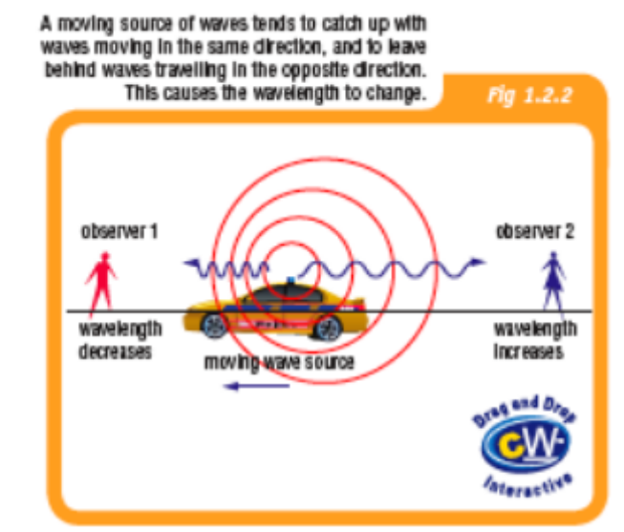
Going away - the frequency sounds lower.
=> Wavelength is apparently larger.

The Spectra Of Stars

When the spectrum of the light from a star is analysed, some dark lines are observed. These correspond to colours of light that have been absorbed by substances in the star.

Different substances absorb different colours of light. By identifying the wavelengths of the colours missing from the spectrum, astronomers can find out which elements are present in the star.

In many cases, missing colours in the spectra of stars are shifted from their expected positions.

• In space, light from the stars appears to be "red shifted" or "blue shifted" due to their
movement relative to our galaxy.

• Approaching - blue shifted (since it has a short wavelength).
Going away - red shifted (since it has a long wavelength).
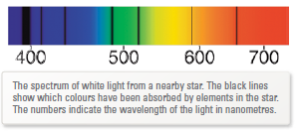
Increasing wavelength (λ)

• Edwin Hubble found a connection between galactic distance and red shift.

• The light from almost all galaxies is red shifted, and the red shift is greatest for the most distant galaxies.

• This means that the speed at which objects are moving away from us is greatest for the most distant objects.

• Almost everything in the Universe is racing away from us, and the farthest objects are racing away faster than those close to us.

• This seems to be true regardless of the direction in which we make our observations.

• We are not at the centre of the universe - space itself is expanding and every part of it is continuously becoming further away from every other part.

• This observation supports the Big Bang theory for the origin of the universe.

